AWS-S3
1.Create an S3 bucket and upload some objects to S3.
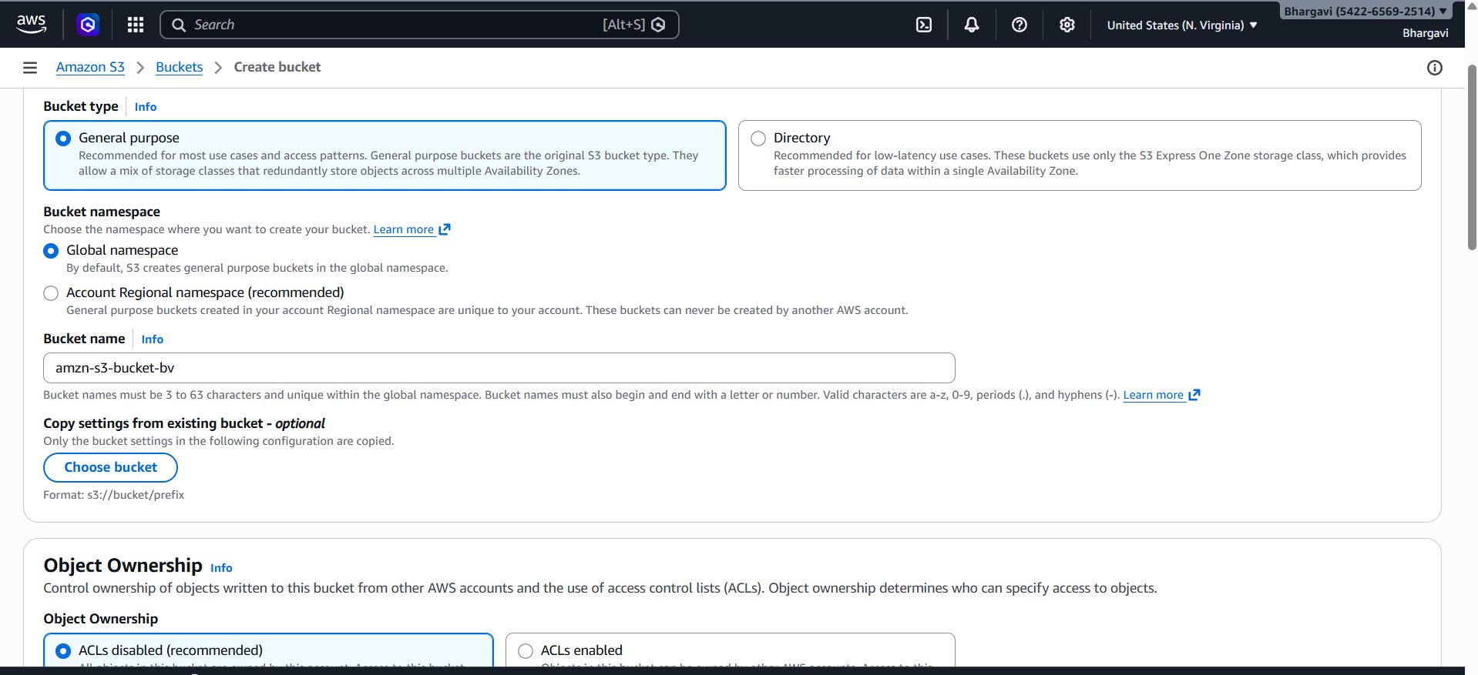
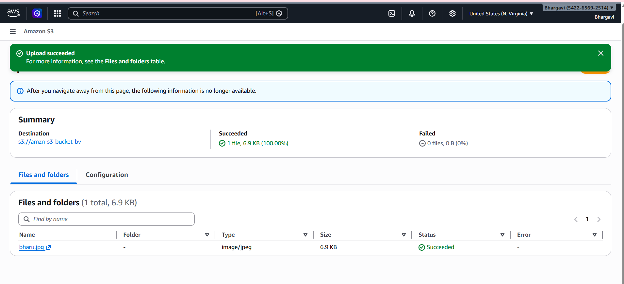
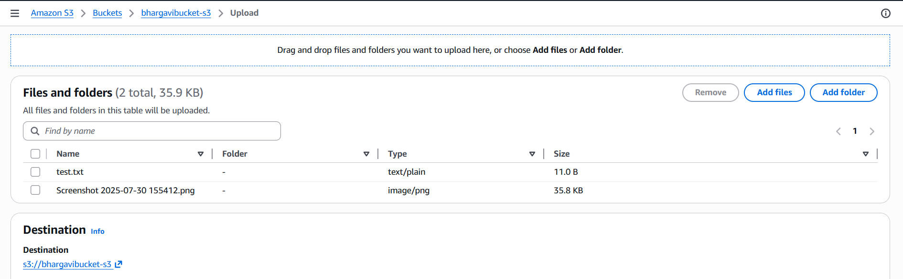
Successfully upload two files
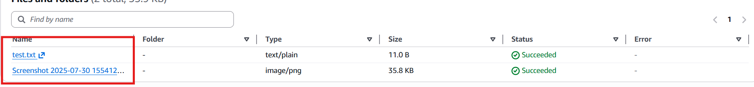
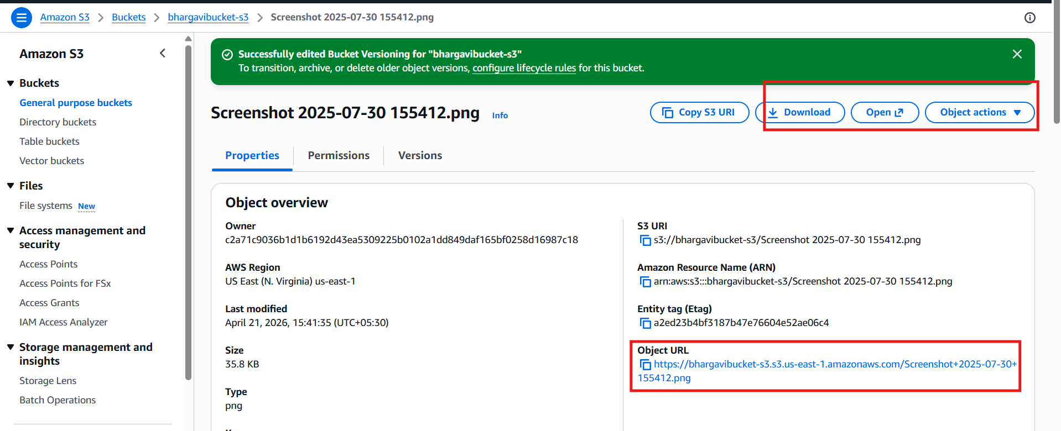
By use this URL we have to check the object url by seen which will be uploaded in google

2.Deploy a static website in the S3 bucket.
Create / Use an S3 Bucket
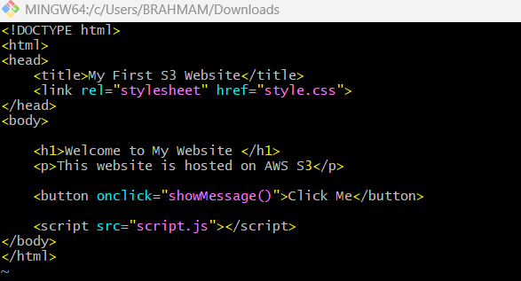
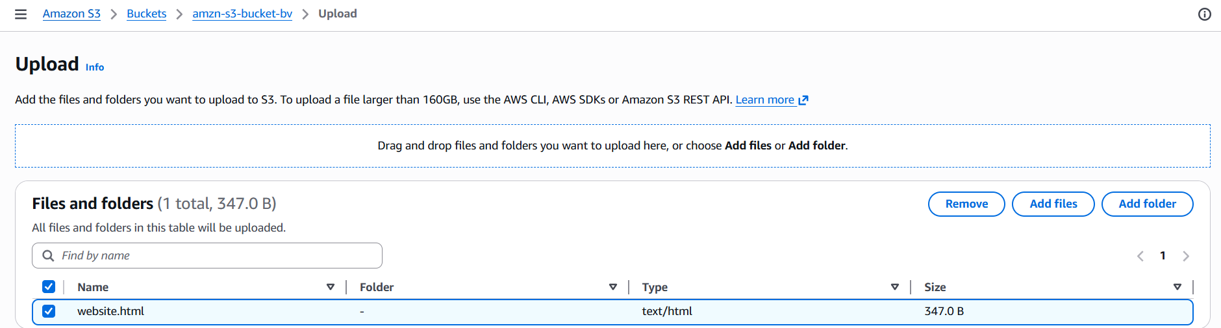

In this bucket we have to create index.html and error.html 2 files using git bash
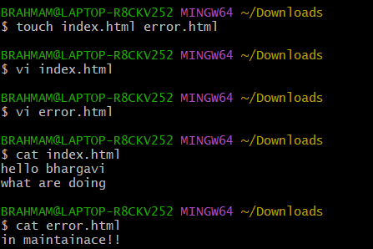
After uploading in bucket usingupload we have to upload this files properties
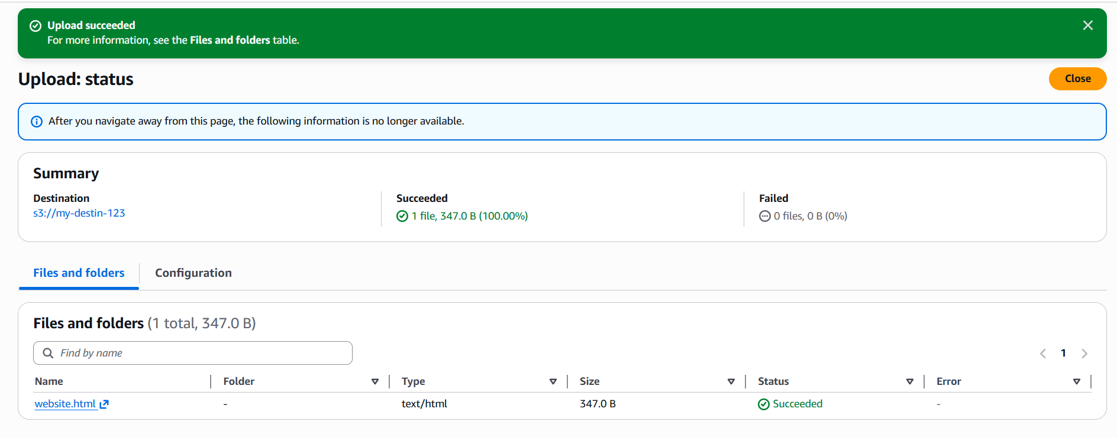
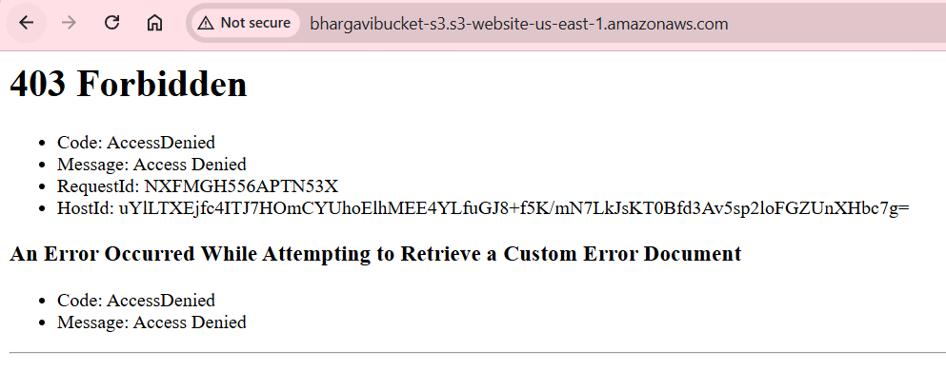
edit ststic website hostingenableindex error.html ->save changes
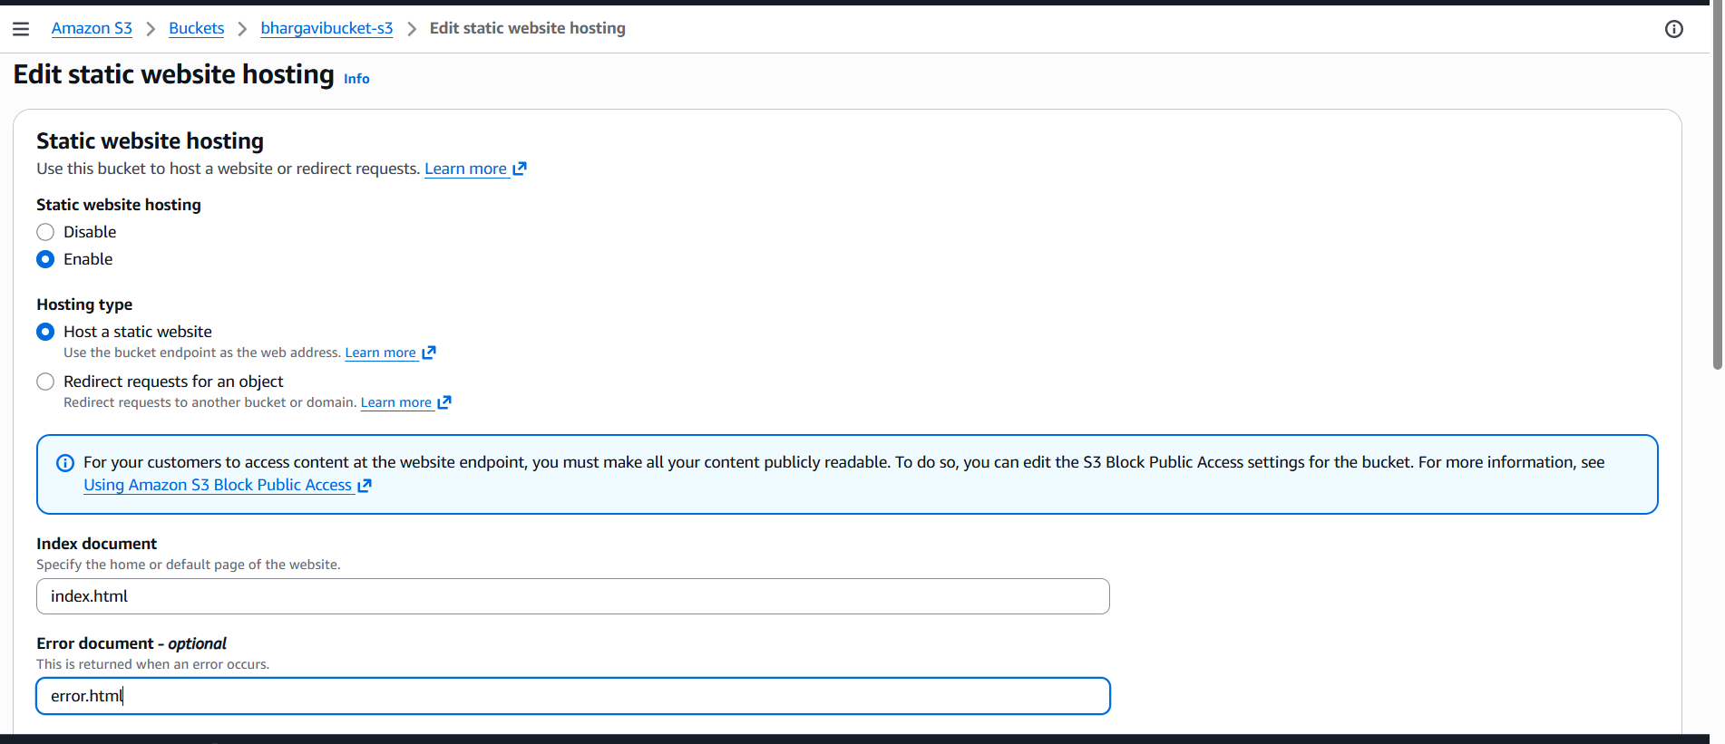
Permissionsdienable all public accessavebucket policy
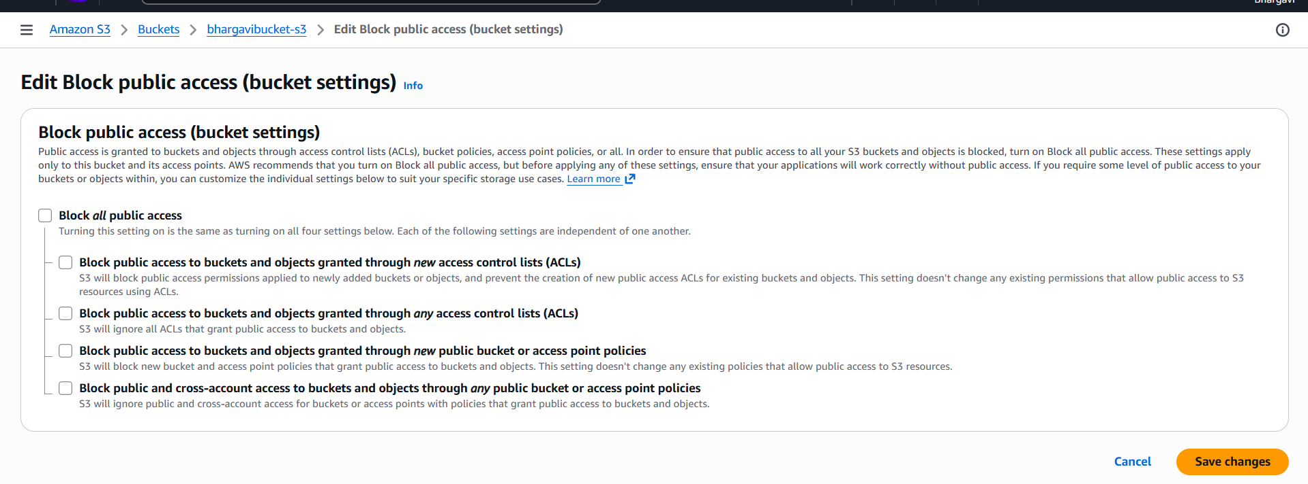
Bucket policy
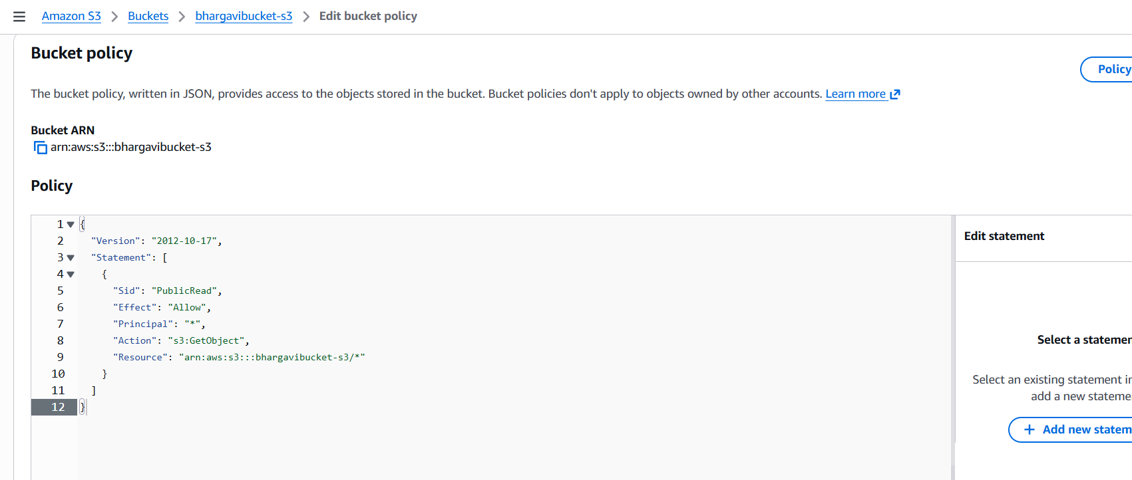
After giving permissions we get this

3.Enable cross-region replication on S3 buckets
Create Buckets (Different Regions)
One with us-east-1
Another with us-west-1
It automatically copies objects from one S3 bucket to
another bucket in a different region.
- As I already have bucket in virginia region, Now I am creating bucket in
different region
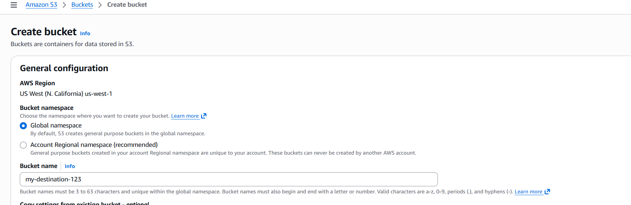
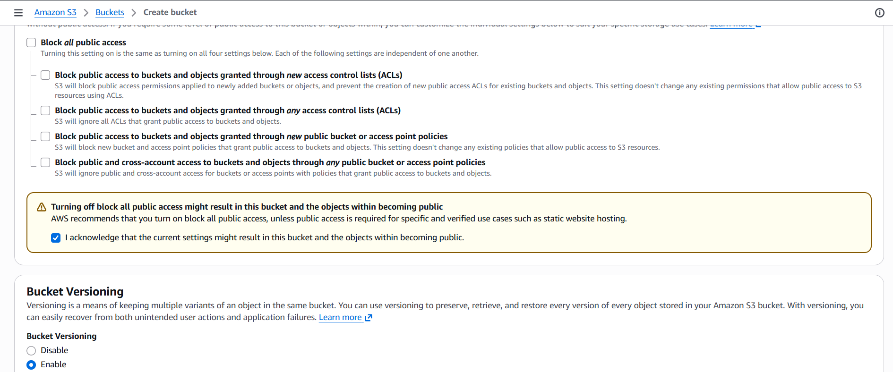
I am creating two buckets with 2 diff regions
-Go to Properties
- Enable Bucket Versioning
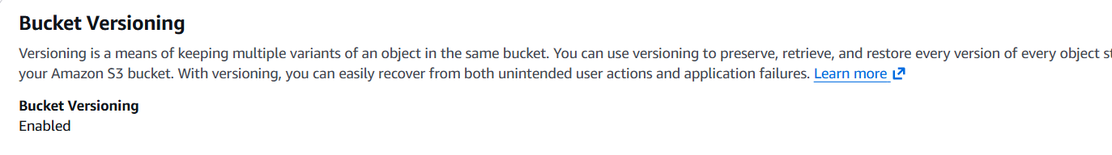
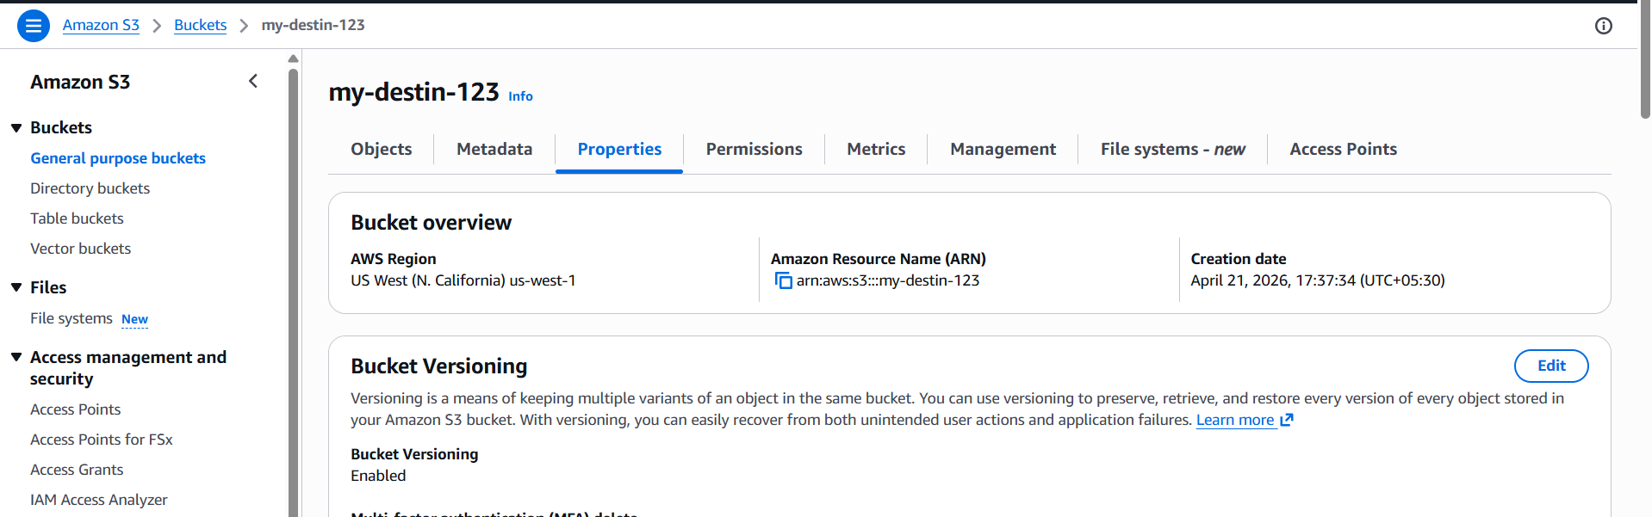
We have to open old bucket and go to managementcreate replication rule
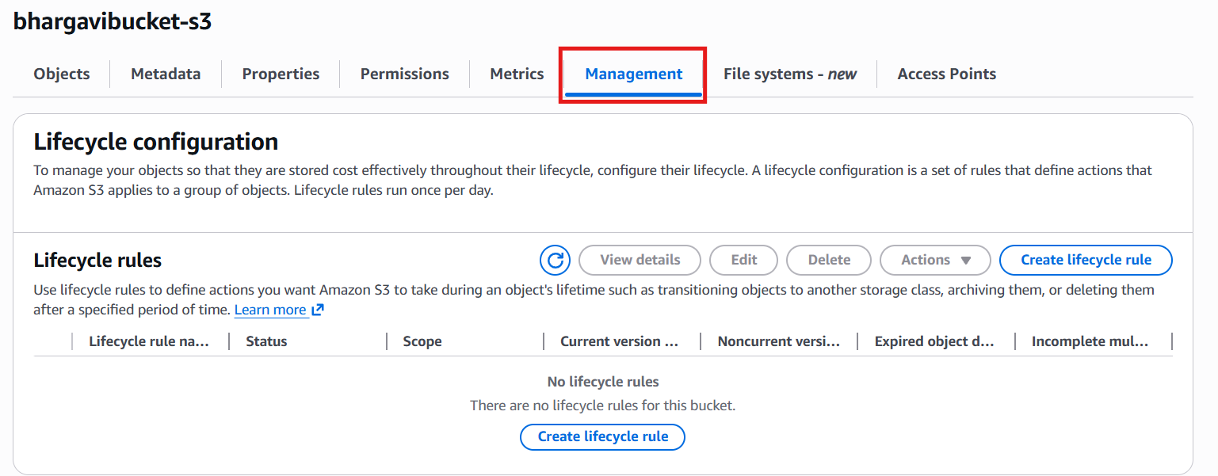
Click on create replication rule on old bucket
Now give the replication rule name → give status as enable→ Choose rule
scope as apply all objects to the bucket
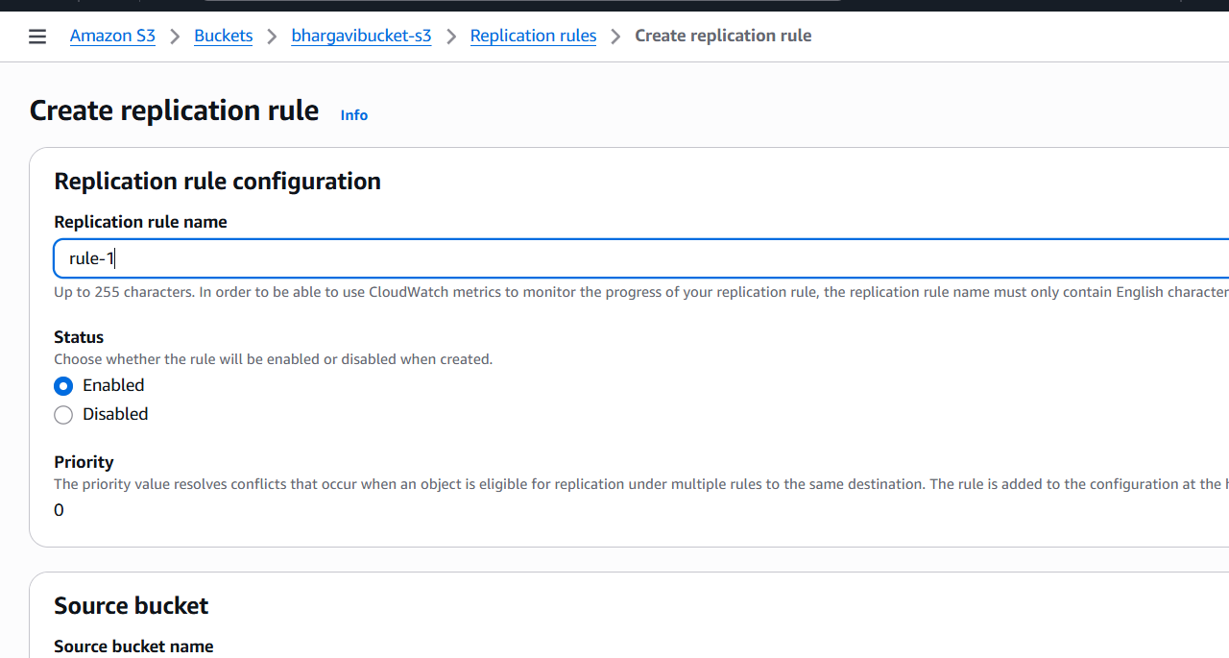
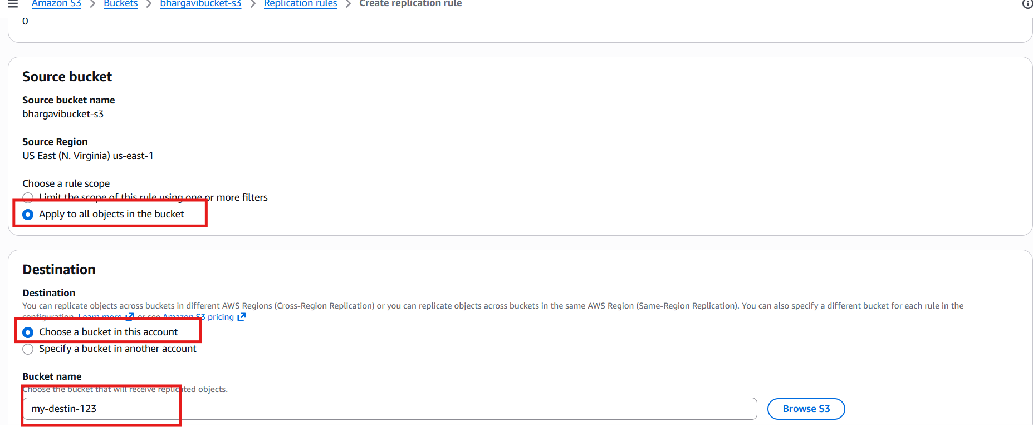
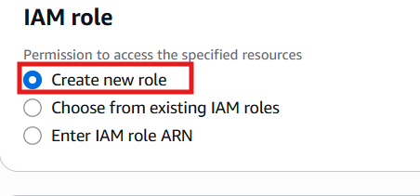
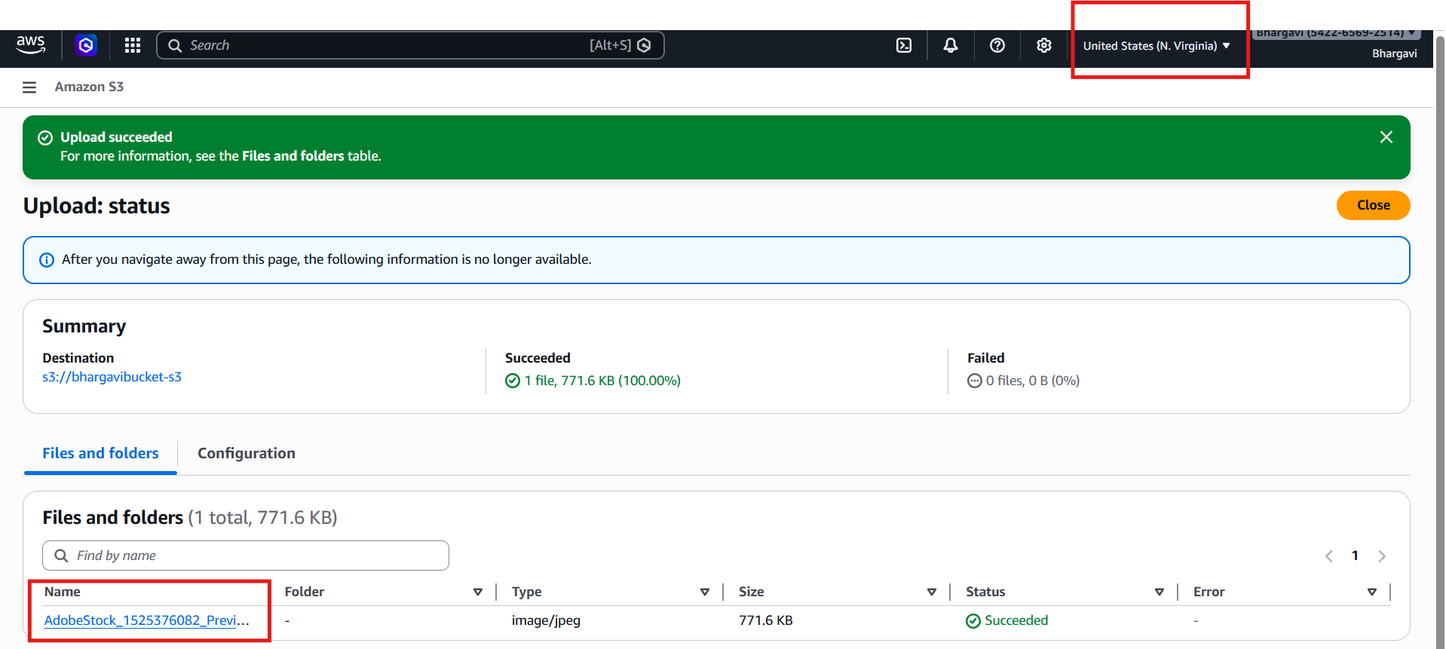
Succesfully replicated file from one region to another region
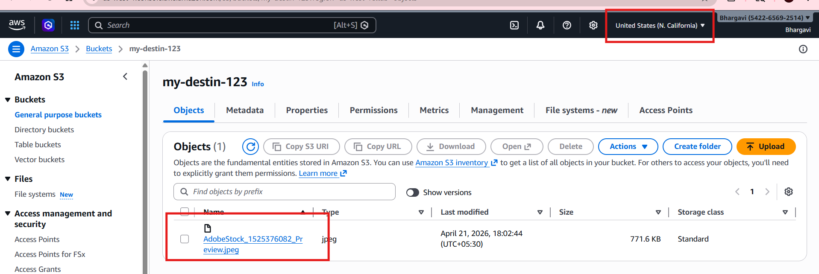
4. Configure a bucket policy so only the Admin user can see the objects of the S3 bucket.
So I gave administrator access to user and copied ARN
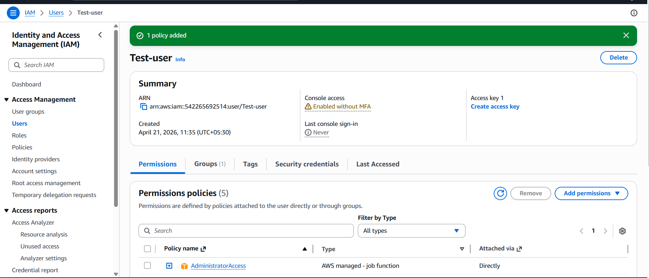
I have added bucket policy by adding user and bucket name
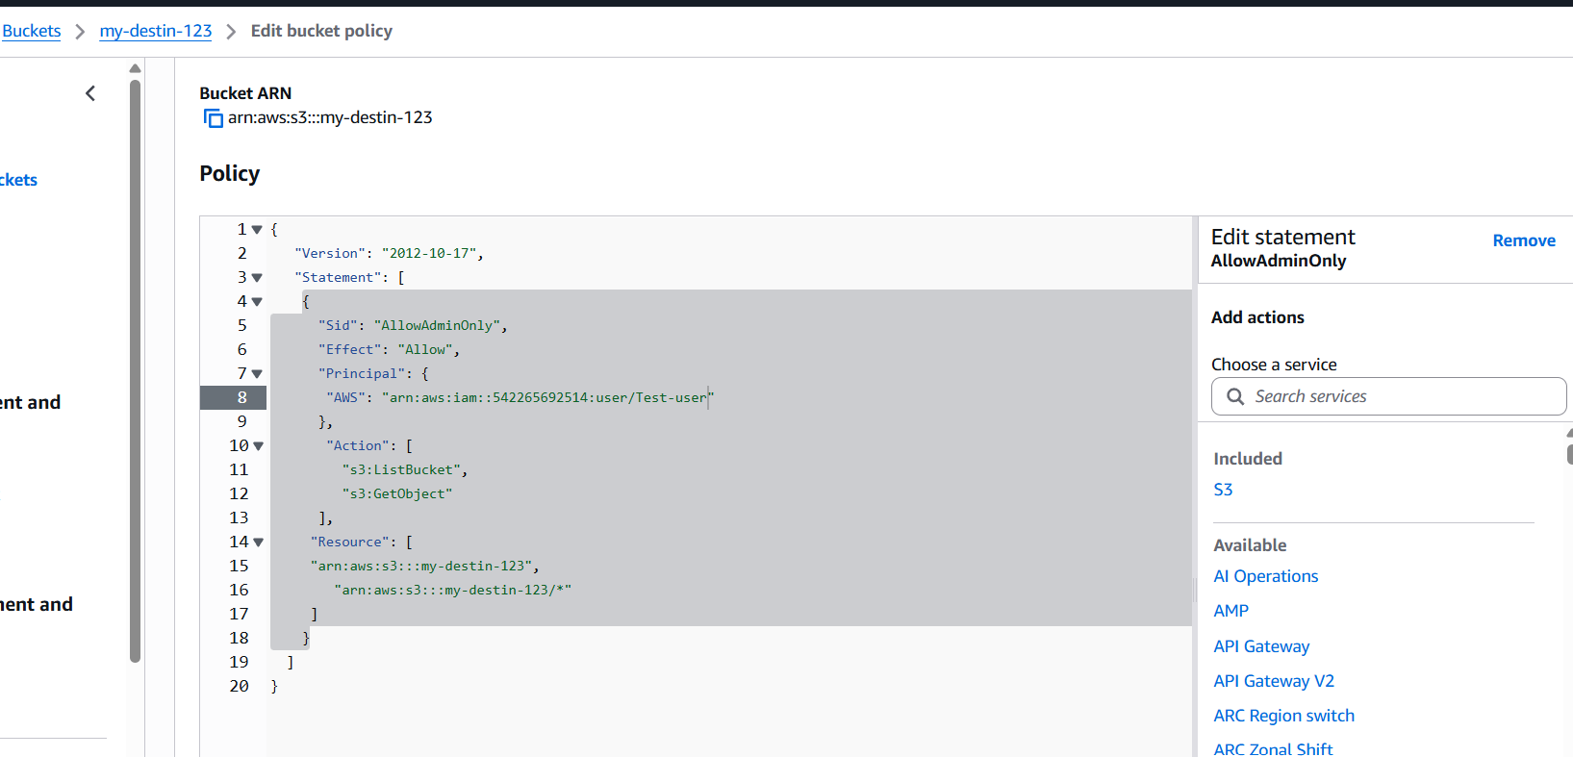
I have totest user name will give in this bucket policyaccess keyaws configure in git bash
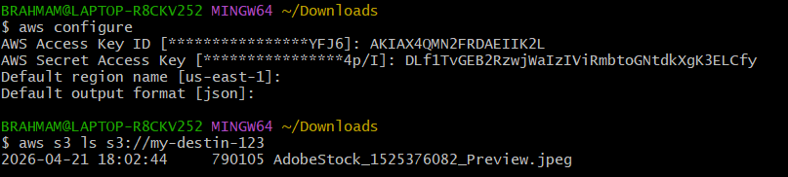
When I tried to access with another user it denied
5. Set up lifecycle policies to automatically transition or delete objects based
on specific criteria.
First go to s3 bucket → click management → click on create lifecycle
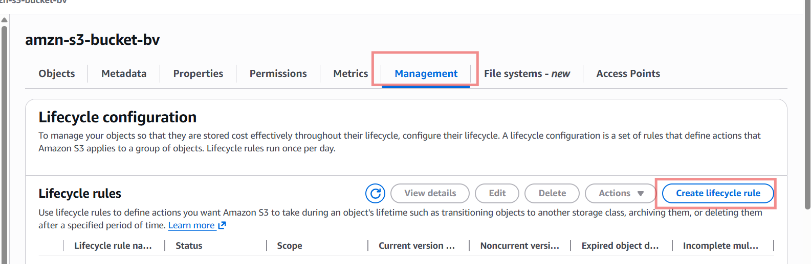
Give the rule name Choose a rule scope
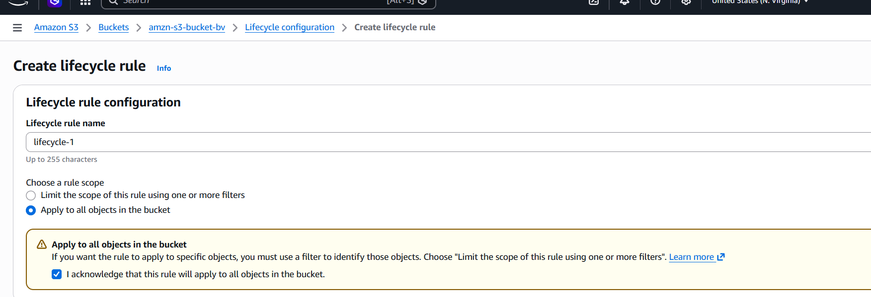
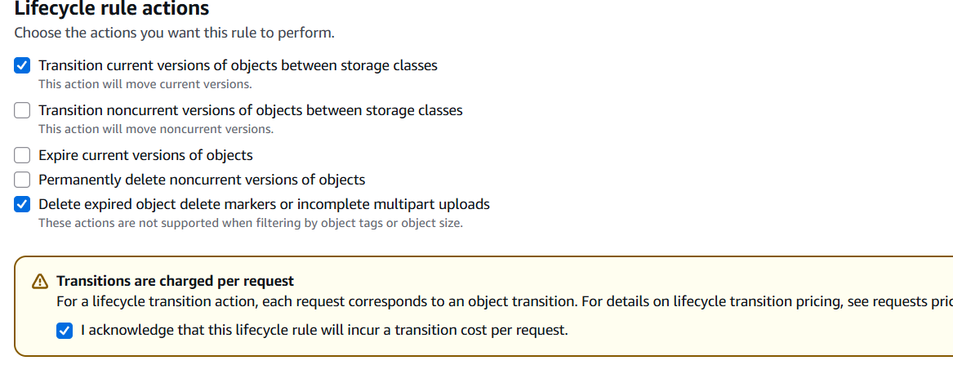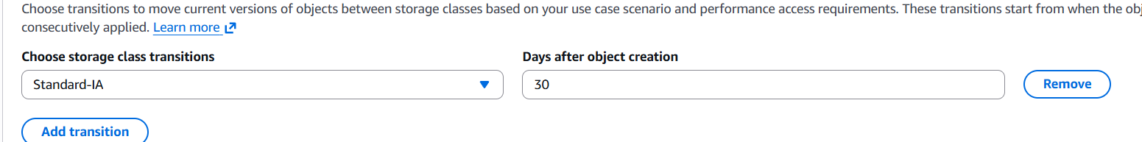
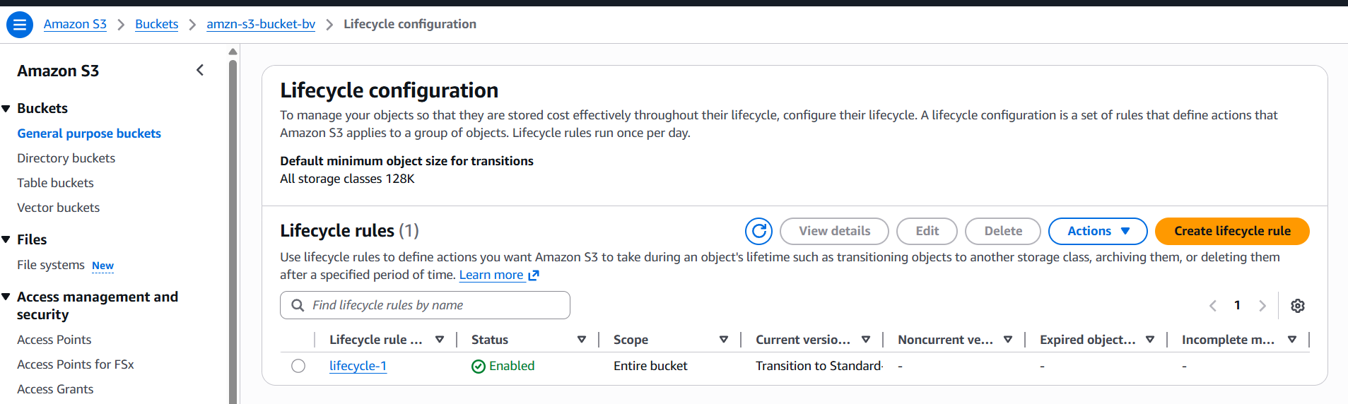
I have verified by checking lifecycle rule
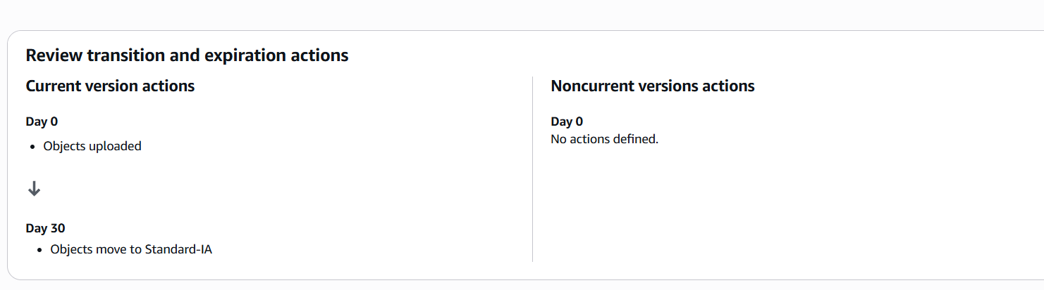
6. Push some objects to S3 using the AWS CLI.
First I have created a txt file with some content through cli
Uploaded this in our s3 bucket
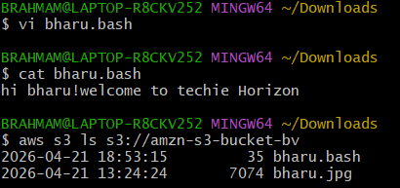
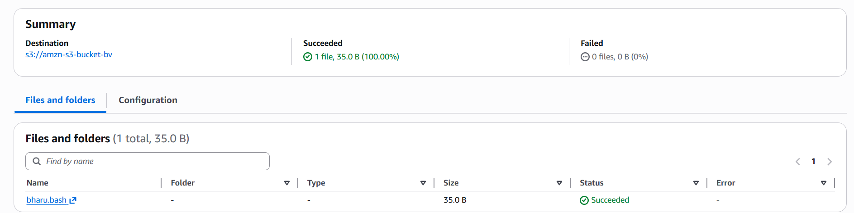
I have checked whether the file is uploaded or not.It is uploaded successfully
7. Write a Bash script to create an S3 bucket.
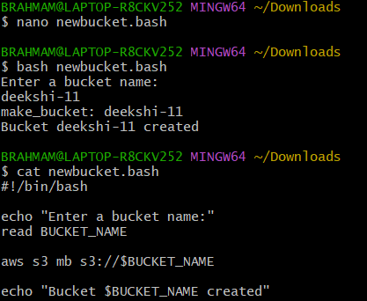
Now I want to check in s3 bucket was created or not.successfully created.
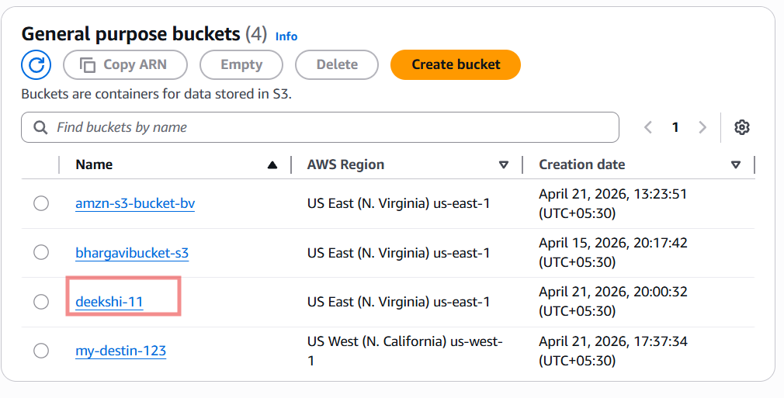
8. Upload a 1 GB file to S3 using the CLI.
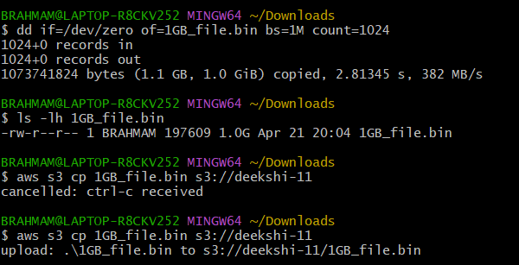
Successfully uploaded 1 gb file to s3 bucket
